**Advance** Excel Assignment 2

1. **What does the dollar($) sign do?**

**Answer:** The dollar sign in an Excel cell reference affects just one thing - it instructs Excel how to treat the reference when the formula is moved or copied to other cells. In a nutshell, using the $ sign before the row and column coordinates makes an absolute cell reference that won't change. Without the $ sign, the reference is relative and it will change.

1. **How to Change the Reference from Relative to Absolute (or Mixed)?**

**Answer**: By default, a cell reference is a relative reference, which means that the reference is relative to the location of the cell. If, for example, you refer to cell A2 from cell C2, you are actually referring to a cell that is two columns to the left (C minus A)—in the same row (2). When you copy a formula that contains a relative cell reference, that reference in the formula will change.

As an example, if you copy the formula =B4*C4 from cell D4 to D5, the formula in D5 adjusts to the right by one column and becomes =B5*C5. If you want to maintain the original cell reference in this example when you copy it, you make the cell reference absolute by preceding the columns (B and C) and row (2) with a dollar sign ($). Then, when you copy the formula =$B$4*$C$4 from D4 to D5, the formula stays exactly the same.

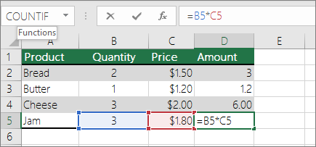

Less often, you may want to mixed absolute and relative cell references by preceding either the column or the row value with a dollar sign—which fixes either the column or the row (for example, $B4 or C$4).

To change the type of cell reference:

1. Select the cell that contains the formula.
2. In the formula bar Button image, select the reference that you want to change.
3. Press F4 to switch between the reference types.

The table below summarizes how a reference type updates if a formula containing the reference is copied two cells down and two cells to the right.

| For a formula being copied: | If the reference is: | It changes to: |
| --- | --- | --- |
| Formula being copied from A1, to two cells down and to the right | $A$1 (absolute column and absolute row) | $A$1 (the reference is absolute) |
|  | A$1 (relative column and absolute row) | C$1 (the reference is mixed) |
|  | $A1 (absolute column and relative row) | $A3 (the reference is mixed) |
|  | A1 (relative column and relative row) | C3 (the reference is relative) |

1. **Explain the order of operations in excel?**

**Answer:** Excel follows general mathematical rules for calculations, which is Parentheses, Exponents, Multiplication and Division, and Addition and Subtraction, or the acronym PEMDAS (Please Excuse My Dear Aunt Sally). Using parentheses allows you to change that calculation order.

**4. What, according to you, are the top 5 functions in excel and write a basic syntax**

**for any of two?**

**Answer:** These are the 5 basic Excel functions that everyone should know:

1. [The VLookup Function](https://gofishdigital.com/blog/5-excel-functions-you-should-know/#VLookupFormula)
2. [The Concatenate Function](https://gofishdigital.com/blog/5-excel-functions-you-should-know/#Concatenate)
3. [Text to Columns](https://gofishdigital.com/blog/5-excel-functions-you-should-know/#Text)
4. [Remove Duplicates](https://gofishdigital.com/blog/5-excel-functions-you-should-know/#Duplicates)
5. [Pivot Tables](https://gofishdigital.com/blog/5-excel-functions-you-should-know/#Pivot)

VLookup Excel Function

Example:

You have a spreadsheet of burger shops, and each individual one is listed out in column A, with their street address, city, state, owner name, annual sales, and other information in adjacent columns.

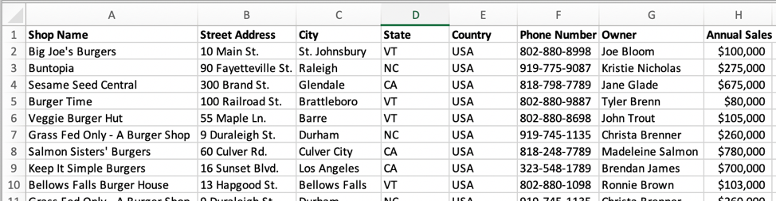

Among your long list of burger shops, there are only a handful you need information about. You could theoretically scroll through the spreadsheet or try to sort/filter the list, or you could use a Vlookup function to pull out the exact pieces of information you need. There are many use cases for this formula, and the more you become familiar with it, the more often you’ll find ways to use it to save yourself some time.

How To Set It Up:

* Create a new table in another tab if you don’t have one created already.

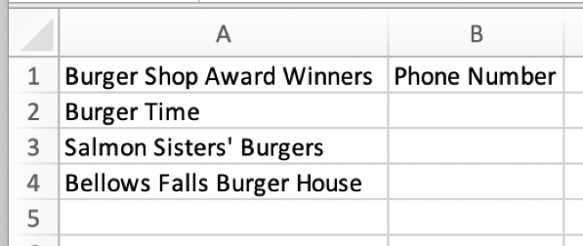

* In the first column, you’ll have the “lookup value,” which is the piece of information you’re telling the formula to look for in your main spreadsheet. This information will need to be in the left-most column of the table you’re telling the formula to look at, as it is in the first screenshot above.
* Then add the formula to the adjacent cell as follows:

=VLOOKUP(lookup_value,table_array,col_index_num,[range_lookup])

lookup_value: The cell where the formula can find the information that it needs to look up in your primary table. In this case, when putting the formula in cell B2, this value would be *A2*.

table_array: The table the formula should search and pull information from. Since my table of burger shops is on the tab named “Burger Shops” and I have data in columns up to column H, this value would be *‘Burger Shops’!A:H*.

col_index_num: This is your way of telling the formula what information you want it to bring back for you. In this example, I’m looking for the phone number, which is in column F in my main table. F is the 6th letter in the alphabet, and so this value in the formula will be *6*.

[range_lookup]: This is a logical section of the formula, where the options are *TRUE* or *FALSE*. If you put *TRUE*, the formula will return a value based on the closest match to your lookup value, even if it’s not the exact one. If you put *FALSE*, then it’ll only return a value if it finds the exact lookup value you referenced. In most cases, and in this burger shop example, we’ll want to put *FALSE*

Final formula:

=VLOOKUP(A2,’Burger Shops’!A:H,3,FALSE)

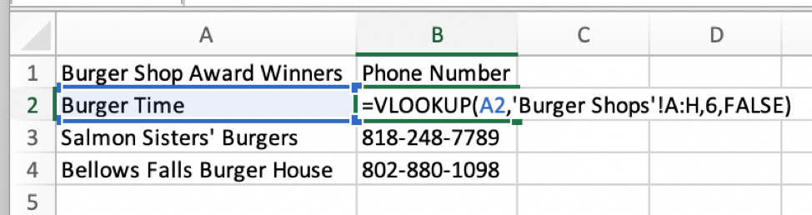

Concatenate Formula

Example:

Continuing the burger shop example, let’s say you want to have the city and state in one column. Perhaps you want to analyze the data by city, but there are cities with the same name in different states so you need them combined. The concatenate function is an incredibly easy formula that you can use to combine the contents of different cells.

How To Set It Up:

* First, you’ll need to add a new column to your table, which is where the new combined data will live

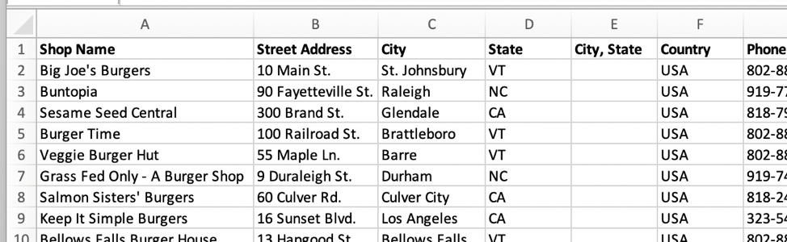

* Next, you’ll add the formula as follows:

=CONCATENATE(text1,text2,…)

You can type text and/or reference cells in this formula, which makes it very versatile. To add text, you’ll just type in what you want and add quotation marks around it. In this example, we’ll want to add a comma and space between the city and state.

Final formula:

=CONCATENATE(C2,”, “,D2)

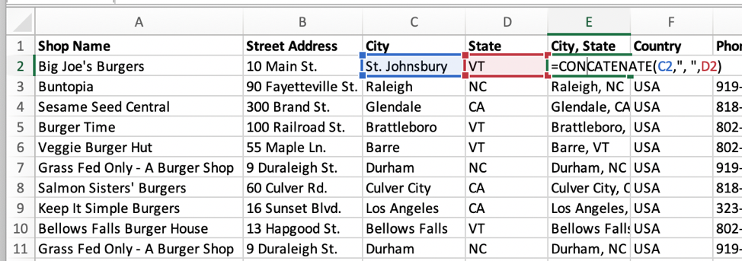

**5.When would you use the subtotal function?**

**Answer:** The SUBTOTAL Function in Excel allows users to create groups and then perform various other Excel functions such as SUM, COUNT, AVERAGE, PRODUCT, MAX, etc. Thus, the SUBTOTAL function in Excel helps in analyzing the data provided.

**Formula**

**SUBTOTAL = (method, range1, [range2 …range_n])**

Where method is the type of subtotal you wish to obtain

Range1,range2…range_n is the range of cells you wish to subtotal

**6. What is the syntax of the vlookup function? Explain the terms in it?**

**Answer:** VLookup Excel Function

Example:

You have a spreadsheet of burger shops, and each individual one is listed out in column A, with their street address, city, state, owner name, annual sales, and other information in adjacent columns.



Among your long list of burger shops, there are only a handful you need information about. You could theoretically scroll through the spreadsheet or try to sort/filter the list, or you could use a Vlookup function to pull out the exact pieces of information you need. There are many use cases for this formula, and the more you become familiar with it, the more often you’ll find ways to use it to save yourself some time.

How To Set It Up:

* Create a new table in another tab if you don’t have one created already.



* In the first column, you’ll have the “lookup value,” which is the piece of information you’re telling the formula to look for in your main spreadsheet. This information will need to be in the left-most column of the table you’re telling the formula to look at, as it is in the first screenshot above.
* Then add the formula to the adjacent cell as follows:

=VLOOKUP(lookup_value,table_array,col_index_num,[range_lookup])

lookup_value: The cell where the formula can find the information that it needs to look up in your primary table. In this case, when putting the formula in cell B2, this value would be *A2*.

table_array: The table the formula should search and pull information from. Since my table of burger shops is on the tab named “Burger Shops” and I have data in columns up to column H, this value would be *‘Burger Shops’!A:H*.

col_index_num: This is your way of telling the formula what information you want it to bring back for you. In this example, I’m looking for the phone number, which is in column F in my main table. F is the 6th letter in the alphabet, and so this value in the formula will be *6*.

[range_lookup]: This is a logical section of the formula, where the options are *TRUE* or *FALSE*. If you put *TRUE*, the formula will return a value based on the closest match to your lookup value, even if it’s not the exact one. If you put *FALSE*, then it’ll only return a value if it finds the exact lookup value you referenced. In most cases, and in this burger shop example, we’ll want to put *FALSE*

Final formula:

=VLOOKUP(A2,’Burger Shops’!A:H,3,FALSE)

